Lawrence Public Library
Directions and Parking Information

Lawrence Public Library Map
707 Vermont Street
Lawrence KS 66044

Note: The parking garage is the structure just south of the library.

Recommended Parking
The city-owned garage is located just south of the library. The main garage entrance is on the east side of the garage (off Vermont Street).

Free
Parking on the top deck (orange level) is free for 10 hours.

Pay
Parking on Level Two and Three costs $1.00 for up to 10 hours. Look for the blue signs. Note your parking space number.

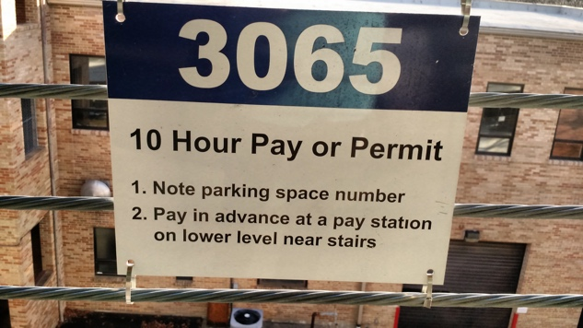

Pay $1.00 in advance at the machine, which accepts credit cards, dollar bills and coins (except pennies). Payment machine is located at ground level on the northeast side of the garage (near the stairs).

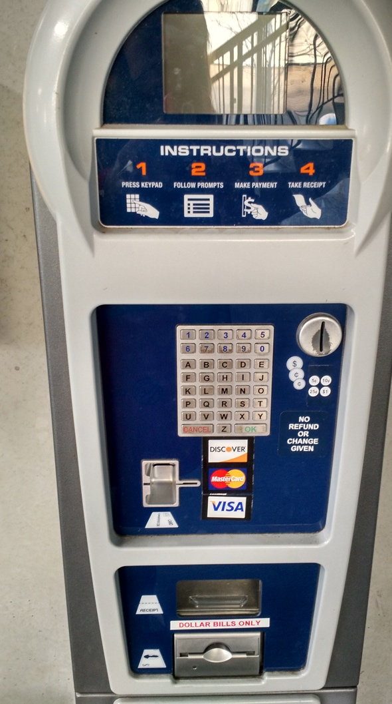

Avoid parking on lower levels (coded with red signs). Many spaces are 2 hours free, but tickets will be issued.

